**Hassan Ijaz Assignment**

Step🡺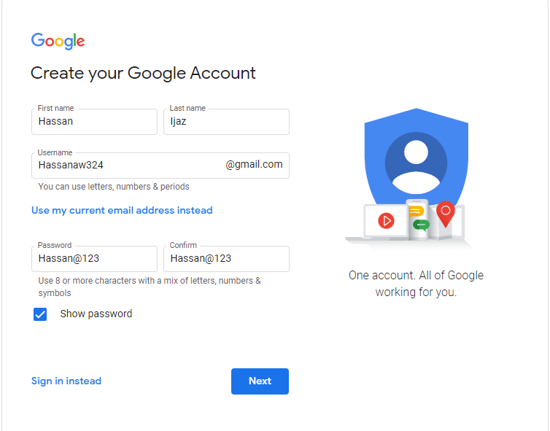

Step🡺2

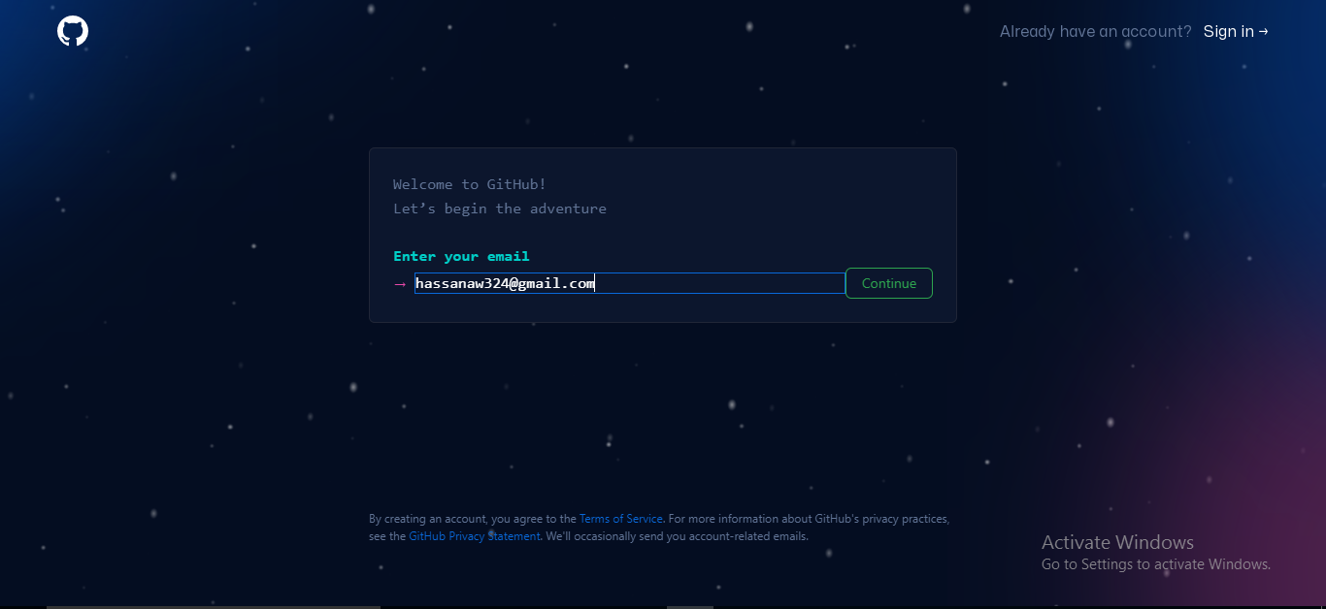

Step🡺3

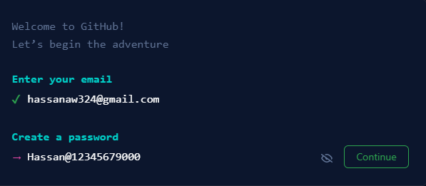

Step🡺4

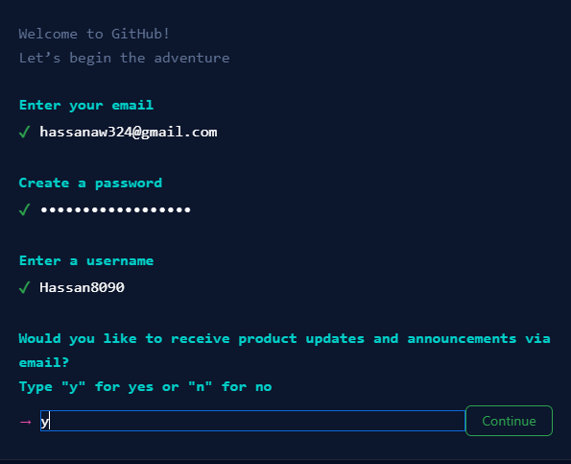

Step🡺5

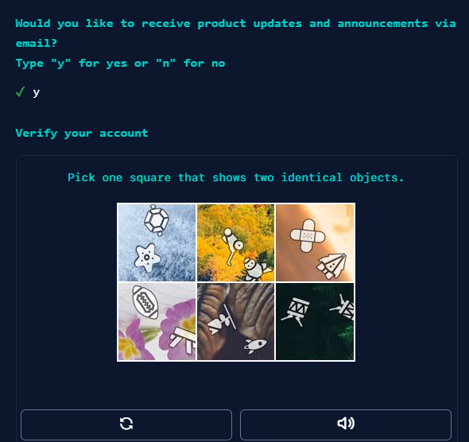

Step🡺6

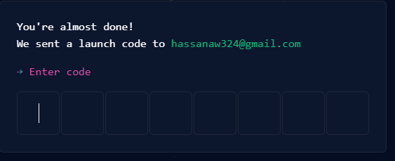

Step🡺8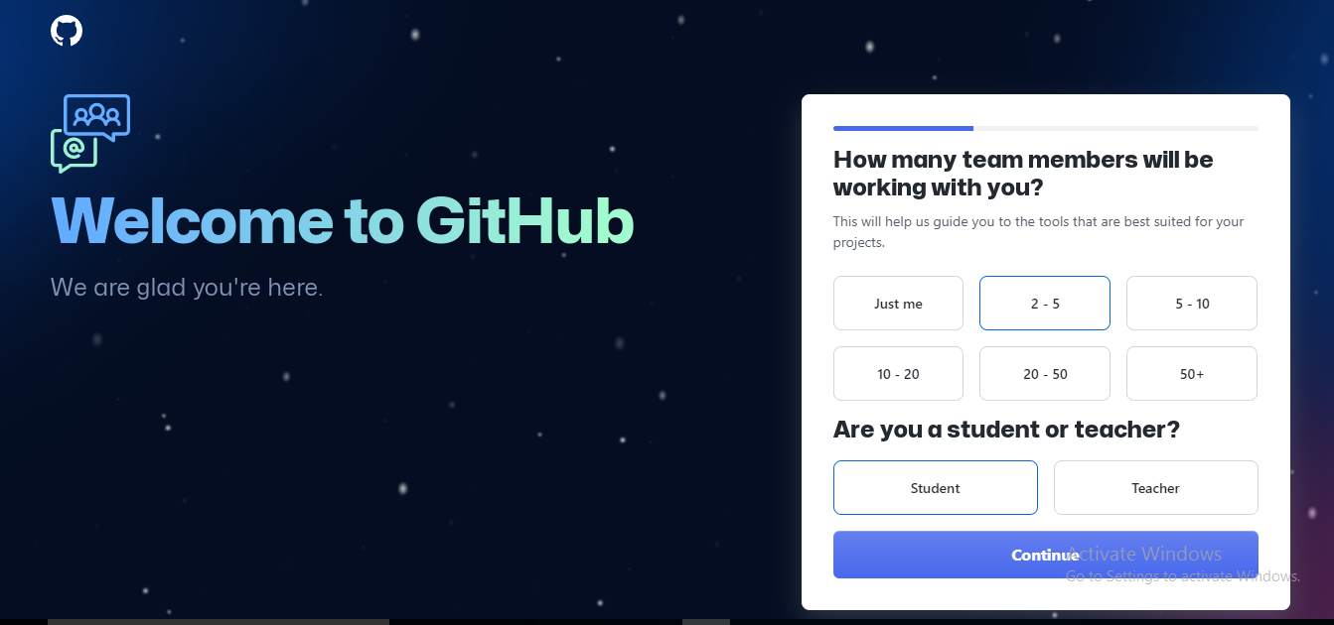

Step🡺9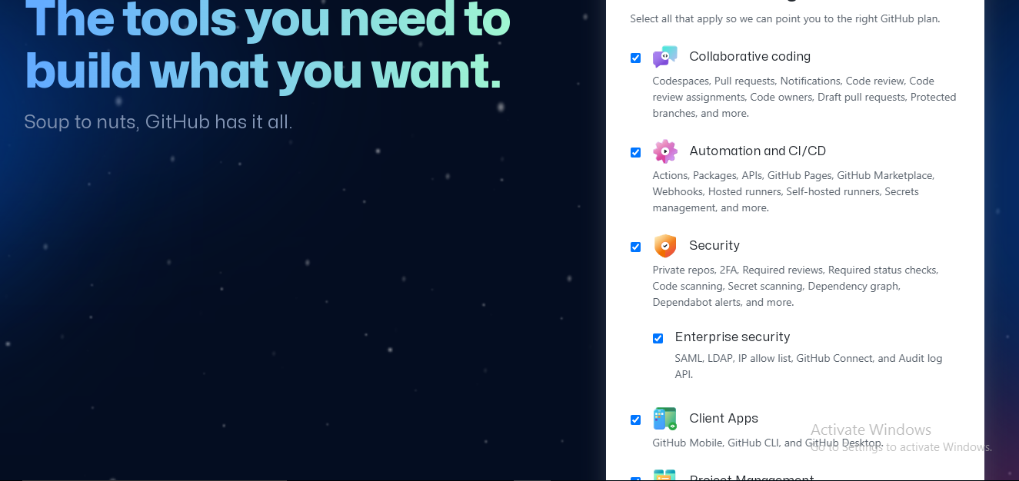

Step🡺10

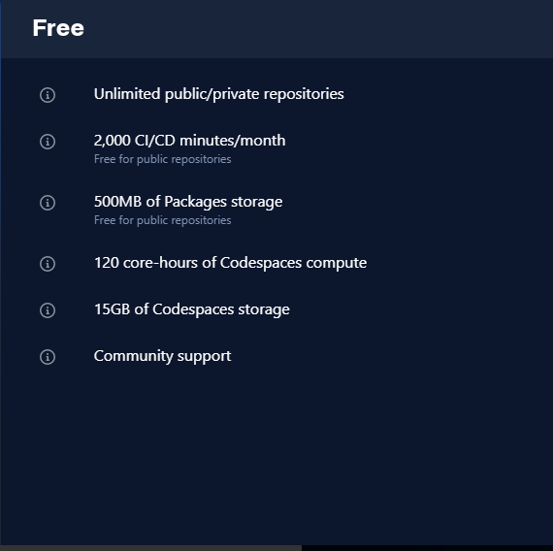

Step🡺11

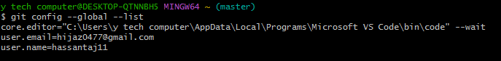

Step🡺12



Step🡺13

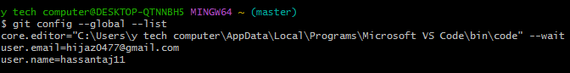

Step🡺14



Step🡺15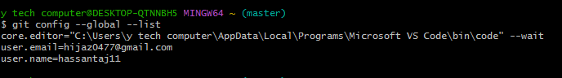

Step🡺16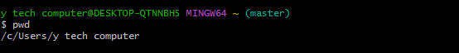

Step🡺17

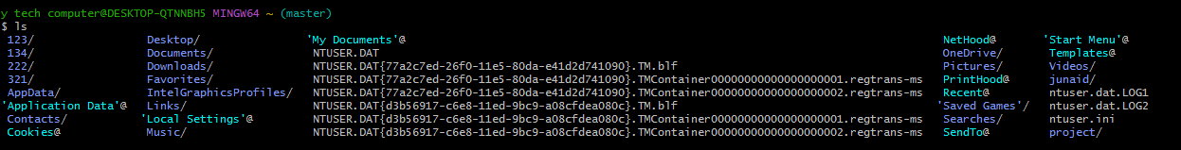

Step🡺18



Step🡺19

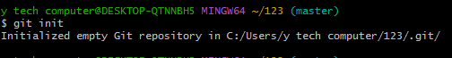

Step🡺20

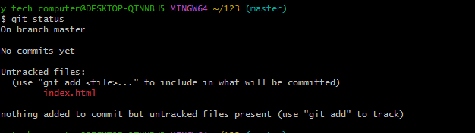

y tech computer@DESKTOP-QTNNBH5 MINGW64 ~ (master)

$ git config --global --list

core.editor="C:\Users\y tech computer\AppData\Local\Programs\Microsoft VS Code\bin\code" --wait

user.email=hijaz0477@gmail.com

user.name=hassantaj11

y tech computer@DESKTOP-QTNNBH5 MINGW64 ~ (master)

$ git config --global user.email hijaz0477@gmail.com

y tech computer@DESKTOP-QTNNBH5 MINGW64 ~ (master)

$ git config --global --list

core.editor="C:\Users\y tech computer\AppData\Local\Programs\Microsoft VS Code\bin\code" --wait

user.email=hijaz0477@gmail.com

user.name=hassantaj11

y tech computer@DESKTOP-QTNNBH5 MINGW64 ~ (master)

$ git config --global user.name hassantaj11

y tech computer@DESKTOP-QTNNBH5 MINGW64 ~ (master)

$ git config --global --list

core.editor="C:\Users\y tech computer\AppData\Local\Programs\Microsoft VS Code\bin\code" --wait

user.email=hijaz0477@gmail.com

user.name=hassantaj11

y tech computer@DESKTOP-QTNNBH5 MINGW64 ~ (master)

$ pwd

/c/Users/y tech computer

y tech computer@DESKTOP-QTNNBH5 MINGW64 ~ (master)

$ ls

123/ Desktop/ 'My Documents'@ NetHood@ 'Start Menu'@

134/ Documents/ NTUSER.DAT OneDrive/ Templates@

222/ Downloads/ NTUSER.DAT{77a2c7ed-26f0-11e5-80da-e41d2d741090}.TM.blf Pictures/ Videos/

321/ Favorites/ NTUSER.DAT{77a2c7ed-26f0-11e5-80da-e41d2d741090}.TMContainer00000000000000000001.regtrans-ms PrintHood@ junaid/

AppData/ IntelGraphicsProfiles/ NTUSER.DAT{77a2c7ed-26f0-11e5-80da-e41d2d741090}.TMContainer00000000000000000002.regtrans-ms Recent@ ntuser.dat.LOG1

'Application Data'@ Links/ NTUSER.DAT{d3b56917-c6e8-11ed-9bc9-a08cfdea080c}.TM.blf 'Saved Games'/ ntuser.dat.LOG2

Contacts/ 'Local Settings'@ NTUSER.DAT{d3b56917-c6e8-11ed-9bc9-a08cfdea080c}.TMContainer00000000000000000001.regtrans-ms Searches/ ntuser.ini

Cookies@ Music/ NTUSER.DAT{d3b56917-c6e8-11ed-9bc9-a08cfdea080c}.TMContainer00000000000000000002.regtrans-ms SendTo@ project/

y tech computer@DESKTOP-QTNNBH5 MINGW64 ~ (master)

$ cd 123

y tech computer@DESKTOP-QTNNBH5 MINGW64 ~/123 (master)

$ git init

Initialized empty Git repository in C:/Users/y tech computer/123/.git/

y tech computer@DESKTOP-QTNNBH5 MINGW64 ~/123 (master)

$ git status

On branch master

No commits yet

Untracked files:

(use "git add <file>..." to include in what will be committed)

index.html

nothing added to commit but untracked files present (use "git add" to track)